CABbaGe Simulator Design

as Learning Media of Heart Coronary Surgeon

in Virtual Reality Concept

Aciek Ida Wuryandari\*1 and Hilwadi Hindersah\*2

*\*School of Electrical Engineering and Informatics*

*Bandung Institute of Technology, Ganesha Street 10, Bandung 40132, Indonesia*

1aciek@lskk.ee.itb.ac.id

2hilwadi@lskk.ee.itb.ac.id

Abstract—**This simulator is expected to help surgeons improve surgical planning and practicing surgery done with 3D models. The simulation results can be evaluated before surgery performed on actual patients. This will help surgeons to obtain a clear picture of the results of surgery. If the surgeon found a few mistakes, he will be able to fix it with a repeat surgical procedure many times until it produces the end result, according to the results that meet the standard surgical procedure.**

**Simulator that successfully constructed to give an idea associated with problems biomodeling heartbeat, tool movement, cutting, and bleeding. The four topics are the basis on making CABbaGe Simulator, which can be further enhanced its development with various features and interfaces of interest.**

Keywords— **biomodeling heartbeat, tool movement, cutting, bleeding.**

1. INTRODUCTION

Heart disease is still the number one disease that causes death in Indonesia (source: http://id.inaheart.or.id). There are various types of heart disease that can be experienced by humans. Handling of heart disease varies depending on its type. Handling the most severe heart disease is through surgery. It is as other surgical operations vulnerable to failure that is fatal to patients who experience it. This may occur because of human error which is due to a lack of flying hours or surgical training. To overcome this, created a simulation application called CABbaGe Simulator.

Cabbage simulator in general is that simulates virtual reality surgical procedure by opening the chest through the sternum bone cuts, continued with the installation of new blood vessels that can be drawn from the radial artery, Mammaria Interna artery or Saphenous vein depending on the needs, the techniques used or the circumstances of anatomic vascular patient's blood. The simulator is expected to help surgeons improve surgical planning and training process of surgery with 3D models. The simulation results can be evaluated before the surgery performed on actual patients. This will help the surgeon obtain a clear review of the results of surgery. If the surgeon found a few mistakes, he will be able to fix it with a repeat surgical procedure many times to produce the final results according to parameters that meet the standards of the dissection procedure.

1. analysis and SYSTEM DESIGN
2. *Heartbeat Biomodeling Design*

Heartbeat can be expressed in simple form with a pulse on the wave principle. Departure from these principles, wave equation is the tool to create a mathematical model of heartbeat. From what appears in the eyes, then poured into the equation by considering the effects of the sinuses, resulting in a mathematical equation.

Due to the computational mesh to create a volumetric (tetrahedral), the calculation of elasticity and mass meetings involving more than one object is very complicated, and also needed adequate processing device, then the design is not limited by factors involving the elasticity and density, and assumes that the volumetric object mesh heart simplified into a triangular mesh. However, the interaction is still influenced by the character of volumetric objects.

Thus the design only involves:  
• triangular mesh (surface);  
• frequency;

• pulse pressure, cardiac volume and pressure force.

Suppose there is a dummy model of the heart, with a triangular mesh topology.

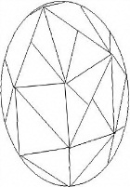















Fig. 1 A dummy model of the heart with a triangle mesh is getting pressure on each cross section

1. *Vessel Cutting Design*

Blood vessels are described as elastic hose, which can be enlarged or reduced in diameter. In the simulation, the blood vessels would be cut by using a surgical scalpel (scalpel). A thin membrane of blood vessels and elastic easy to change shape very easily broken even, so that the force imposed on the blood vessels that can be cut is not big.  
Scalpel as a cutting tool having a rigid properties but can be driven (not fixed). Cutting will occur when the scalpel as a tool in contact with blood vessels. Then with a force that bears the vessel will separate the particles in the blood vessels so that blood vessel is cut off. Compiler particles mesh of blood vessels represented by the constituent. Cutting can occur if there is removal of mesh when a blood vessel collides with the blade.

Simulation of cutting blood vessels is designed by using the method of removal of mesh on the surface. By considering the collision detection, when the scalpel is said to touch the surface of blood vessel, then that happened which means elimination of mesh cutting has occurred. Blood vessels are represented as small cylindrical tubes consisting of tetrahedrons that are interconnected. Tetrahedrons are constructed by points in the form of DOF which contains information about the position, speed and force. Then by using the finite element, the tetrahedron is split or discrete points to elements that are smaller, i.e the triangle, which contains the same information with the tetrahedron, as its domain.

Schematic process of cutting blood vessels as follows:

* Follow the trajectory of the blade moves toward the blood vessels
* In case of contact between the knife and blood vessels
* Topology mapping from tetrahedron to triangle
* Remove tetrahedron
* Stop scalpel cut after cut off the blood vessels

1. *Trajectory of Scalpel Design*

Trajectory is the path to be traversed by a surgical scalpel toward the object. Designed trajectory should be moved to follow the appropriate path to mimic the position and orientation of a surgical knife every time. To create a realistic trajectory approaching the original motion, need to define the appropriate parameters. Trajectory receive input of the coordinate axes of x, y and z and the rotation angle of yaw, roll and pitch in a time (t), which is mapped into the position and orientation of the movement of the scalpel as the output.

Based on this analysis, the equations are converted to build a trajectory.

To make the trajectory simulation of scalpel movement, composed of a simple algorithm as follows:

* input the number of points in time;
* input point coordinates and angle of rotation according to the number of point in time;
* calculate the value of *x, y* and *z* and the angle of rotation between the coordinate points;
* show the new ones of position and orientation.

1. *Bleeding Design*

Bleeding is the blood flow from a ruptured or open blood vessel. In the simulation, bleeding occurs due to cutting of a blood vessel that is a part of the process on the Cabbage Simulator. Blood flow in the human body is influenced by many factors which are all arranged in circulatory physiology. Because this is too complex to be applied in the simulation, so in this simulation, the physiological factors are not taken into account.

The blade is moved to the blood vessel pembuluh darah

The blade cuts the blood vessel

Blood flows from the cut

Blood flows is retained by a plane

Fig. 2 Bleeding simulation scheme

Blood flows from where blood vessel is cut. Blood flow is created when a blade cuts the blood. Blood will be retained by the plane that is visualized as a table.

To model fluid dynamics that approximates real condition, required an appropriate method. The most complete method for modeling fluid dynamics is the SPH method. With this method, blood is modeled as particles of the points in 3D space that have attributes such as mass, velocity, and position and have quantity of physical field such as density and pressure.

Bleeding in this simulation is generating particles from slaughter when the blood vessel is cut. Generating particles is performed several times with certain time intervals until the time set to indicate the presence of blood flow in blood vessels. Particles that fall to the bottom will be retained by the flat plane. Blood flow is only affected by gravity and SPH force.

Based on the explanation above, the following are things that are done prior to simulation or pre-simulation.

1. Determining the location of cutting the blood vessels.
2. Determining the values of movements and keytimes parameters of the blade from the beginning to the end position. The movement of this blade must pass through a predetermined cutting position.
3. Putting points of particle source at the location of cutting blood vessel that had been predetermined. Source points of particles is an object in which the particles are generated. Generating particles is occurred at the time the blade cut blood vessel, which means that keytime blade cuts the blood vessel is the same with the time of the particles generated for the first time.
4. Determining the value of other parameters.
5. iMPLEMENTAtion and testing

Once the design is done, the concept has been created is poured into the SOFA implementation with the assistance framework. This framework has a variety of files that support the establishment of medical simulation, which has 41 modules which include sofacomponenforcefield,

sofacomponenconstraint, sofacomponencollision, and so forth [4]. Each module has its own duties as a module for cutting, a module for bleeding, a module for the collision, and others. In SOFA, the module for the heartbeat has not been created. For that made the module builder heartbeat. Files created are DetakSinusForceField.cpp, DetakSinusForceField.h, and DetakSinusForceField.inl. These three files are integrated into the module sofacomponenforcefield.

1. Implementation

Here is the heart of the display object viewed in detail from various models.

|  |  |
| --- | --- |
| jantung behavior (crop) | jantung collision(crop) |
| jantung mapping (crop) | 6 titik fixed constraint(crop)  Fixed constraint |

Fig. 3 The object of the heart from various models

From the results of the application, if examined more closely, the object of the heartbeat properly when combined with three other topics (see Introduction). Combined simulation takes place at 14 fps frame rates are in line with simulation time, decreases slowly as a result of increasing the number of particles

The simulation illustrates how cutting the blood vessels in general cutting of tissue. Program created in C + + with Simulation Open Framework Architecture (SOFA) and Microsoft Visual Studio 2008 as IDE.

|  |  |
| --- | --- |
| serius_22 | serius_22 |
| a | b |
| serius_22 | serius_22 |
| c | d |

Fig. 4 The visualization of heartbeat on simulator CABbaGe

Implementation was divided into two stages.

1. Pre-implementation stage is the object creation phase of the blood vessels and a scalpel. Objects created with 3ds max software, and for making it mesh used Gmesh software. Object of blood vessels is described as a cylinder which has a thickness. Preparation begins with the placement of mesh points is set mainly in the area to be cropped, so that cuts smooth. After that the dots are connected, forming triangles that form a tetrahedron-tetrahedron.
2. Implementation stage is the stage of making the simulation program cuts the blood vessels using SOFA by defining the nodes and components required, and defines the algorithm used

Using SOFA is intended to accelerate the implementation process because it can use the facilities provided. SOFA is composed of modules that can be used as needed, for it to compile a program with the SOFA, the programmer can just choose the modules according to needs, determine the parameters of the simulation, and add some programs if needed.

Implementation stage is the stage of merging all the system requirements described in the system design into a program. Programs that will be built is a program that can be run in GUI SOFA. The program created is the file which has extension of xml. The program contains the nodes and the components required in the simulation. All nodes and components are depicted in the scene graph.

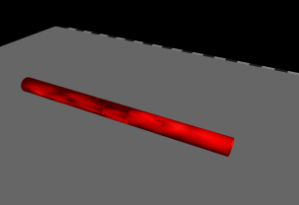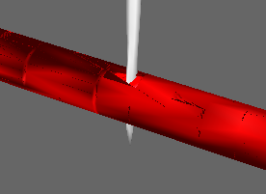

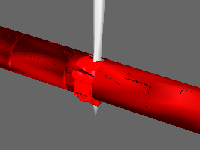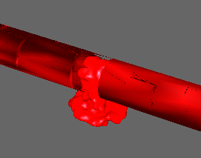

Fig. 5 Screenshot of the simulation result

1. Testing

The model was built by the heartbeat parameters are determined based on the existing literature.

The first test conducted on aspects of fixed constraints. The design set a fixed amount of biomodeling constraint is built as much as six points (see Fig. 3). These points can be said to function as a drag objects to remain on the basic position for interacting objects.

If the amount was deducted one point from all the existing point, then the object will gradually change position during the simulation in progress. Meanwhile, if plus point constraint him, the heart of the object's position has not changed. Total fixed constraint taken the least but still be able to perform the function properly.

The second test conducted on the value of stiffness at the heart of the object. At the selected object, made the default value 4000, while testing is done on the value of 400, 3999, 4001, and 40 000. When stiffness is at a value of 400, then the object interacting irregular heart. On the value of stiffness 3999, and 4001, the heart of interacting objects is almost similar to the object of his dafault rated. While for the stiffness value 40 000, the objects interact with the quality of heart is very weak pulse.

The third test performed on the value of damping . The default value for the damping set was 4. Tests conducted on the value of damping 10 and 100. When damping value 10, the objects interact with the heart that beats quite smooth. Whereas the model with a damping value 100, the objects interact with cardiac heartbeat is very rough.

The fourth and fifth tests performed on the load deviation per unit area (pressure) and frequency of pulse / heartbeat. Two of these tests are in one parameter on DetakSinusForceField. For the deviation of the load per unit area, the default value taken is 200. Tests carried out at a pressure of 2, 20, and 2000. At the time of the pressure value 2, the total pressure force can be calculated in an area. While for the pressure value 20, even more areas that get the style press, and for the pressure value in 2000 resulted in many style press that occurred in the object area so that the resulting pulse becomes irregular and the deviation of the position of cardiac origin object

   For the last testing, i.e testing the heart rate, the value being tested is the one and 90. The default value used is 2 with a frame rate of 60 fps. At a pulse frequency value, of course, so move slow pulse. Meanwhile, when given a value of 90, moving very fast pulse.

In vessel cutting design, to determine the effectiveness and efficiency of the algorithm used in testing the system on a single parameter value, namely the coordinates of the trajectory and use the other parameter fixed. Number of mesh used was 4195 tetrahedron, so it can display a near realistic visualization cutting. Tests are conducted to see whether the cuts to be made of different cuts. That is, the test aims to test whether the collision detection and removal of mesh can be done on the whole surface of blood vessels? To test this, changing the coordinates of the trajectory carried knives. Testing will be done by cutting the horizontal and vertical directions. Horizontal direction is a direction of the blood vessels cross the blood vessels, while the vertical direction is the direction of the blood vessels.

In the first test will be done by using the coordinates of the cutting trajectory as follows.

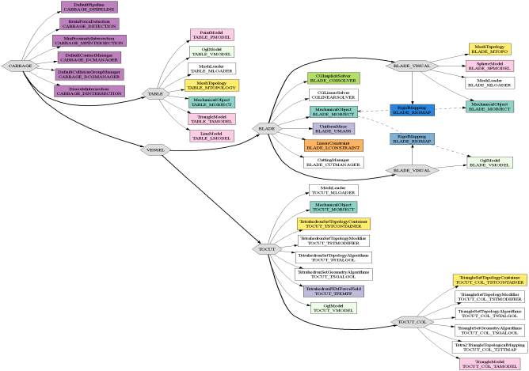

Fig. 6 Scene graph of cutting vessel

The second test is to change the trajectory coordinates of the blade with the vertical direction or the direction of the blood vessels.

In addition to converting the coordinate position (x, y, z), is also changing the direction of motion scalpel (α, β, γ), so that the direction of movement of the blade also becomes vertical. X and y coordinates are always at fixed positions, while the z coordinates of moving from 35th position up to -35.

In trayectory of scalpel design, the test is done by setting the value of the parameters of position and the appropriate of rotation angle, so the trajectory can be run as designed. To enter the value of the parameters, created a kind table, so that users can modify the trajectory to meet the needs of each. In the table provided the following columns.

* K*eyTimes columns*

Serve as the input time (*t*) for the trajectory. Time in second (*s*)*.*

* M*ovement columns*

Serves as the input position  *(x, y, z)* and angles *(yaw, pitch, roll)* for the trajectory. Angle in units of radian.

C. Discussion

By collecting the output data generated in this simulation, obtained the values of the parameters written in Table 1.

Table 1 Parameter values that have been adapted to simulate a heartbeat

|  |  |
| --- | --- |
| **Parameter** | **Value** |
| Number of Fixed constraint | 6 |
| Stiffness | 4000 |
| Damping | 4 |
| Frequency of heartbeat | 2 Hertz |
| Deviation pulse pressure force | 200 |
| Frame rates | 60 fps |

The values mentioned above are the result of selection of the many values that have been tested. The frame rates are used depending on the specifications of existing computing devices.

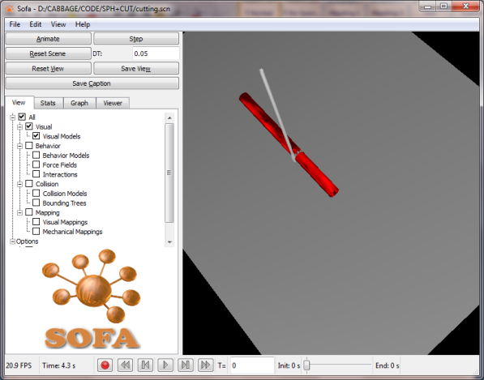

Fig. 7 Views simulations when there is cutting in a horizontal direction

     The frequency used is the frequency of subsequent heart rate applied in the equation that has been written before. Although the source of guidance on the normal human heart rate expressed in value 60-80 ppb (some are mentioned 60-100 bpm), which if converted into hertz is one per second, but taken as a default value is 2. This is done to achieve the goals in the beginning, which displays the heart rate model that can be said to approach the original model. This value is modified unit in accordance with the value of a unit of frequency, namely Hertz (Hz). Frequency pulse is applied to the value of existing frequencies in the wave equations that have been designed previously. For the deviation of the pressure pulse, taken the value 200. Cardiac pressure deviation is a measure of deviation of object position fixed point constraint heart against him. This needs to be calculated to support the fixed function constraint.

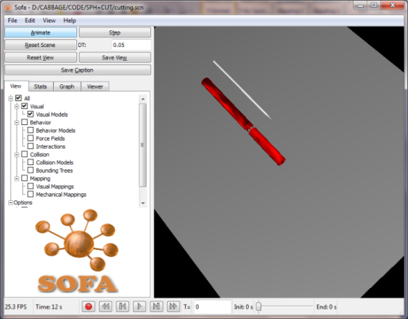

Fig. 8 Views simulations after cutting

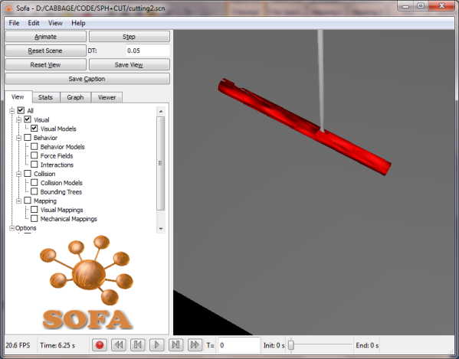

Fig. 9 Views simulations when the scalpel cut the vertical direction

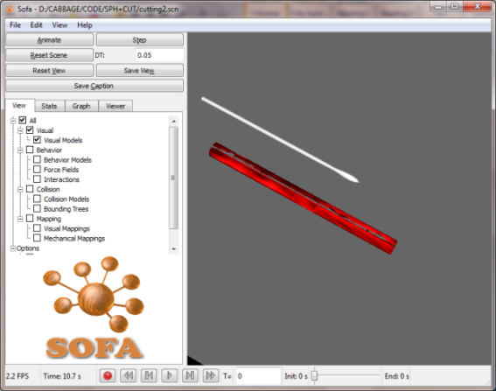

Fig. 10 Display after the blood vessels cut off with the vertical direction

All the tests were performed to determine the effectiveness and efficiency of the algorithm that is used in a system that involves the determination of parameters that can display the smooth visualization of the scalpel movement.

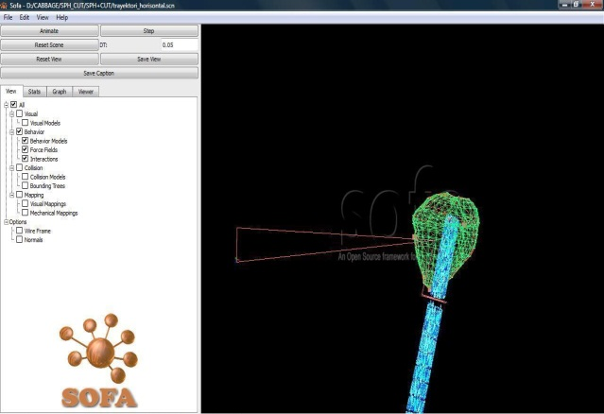

Fig. 11 Trajectory of scalpel movement in horizontal position

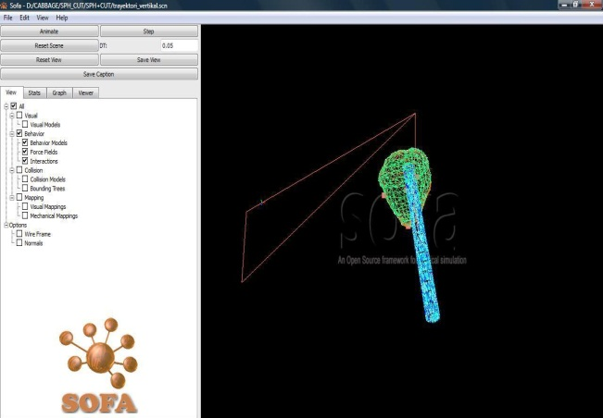

Fig. 12 Trajectory of scalpel movement in vertical position

1. CONCLUSIONS

# The conclusions of the implementation and testing has been done is as follows.

1. Biomodeling heartbeat that has been created, but still limited to the visualization of the nature of heartbeat and has not penetrated to the graphic design aspect which approximates the original, so it can be said that the supporters of the application of this simulator is not a perfect simulator as expected.
2. Simulation of cutting blood vessels can be simulated by using the SOFA by eliminating the triangular mesh on the surface with topology changes are made in advance of the tetrahedron into triangles. This causes the blood vessels of the missing part (cut section), whereas in reality the cutting process does not eliminate the section cut.

# Simulation of cutting with the methods used are still visible because the number of coarse mesh, which is still slightly, causing the size of the triangle that formed little less, so that when the removal of the triangle formed blank spaces marked. Cutting can be done in every area of blood vessels, both vertically and horizontally.

1. Determination of position and orientation parameter values of the scalpel is done by testing manually. This was done so that the simulation can mimic the actual movement of the scalpel. From designing and implementation, simulations of scalpel movements can be modified by altering the trajectory parameter values that are displayed on a table.
2. Fluid model with SPH method can be applied to simulate bleeding according to the design and implementation has been done.
3. Nevertheless, this research is still early prototypes that still must be perfected in all aspects. The results obtained, requires a follow-up to a better development.

ACKNOWLEDGMENT

Thanks to School of Electical Engineering and Informatics, Institut Teknologi Bandung as the organizers ICEEI 2011 that has given us the opportunity to contribute.

References

[1] Martini, Frederick H., *Fundamentals of Anatomy*

*& Physiology: The Heart*, 7th Ed., Pearson education Inc.,

California, 2006.

[2] Ridwan Hanri K.*, Studi Gerak Jantung Menggunakan MetodePengolahan Citra dan Transformasi Fourier*, Tugas Akhir, Institut Teknologi Bandung, 2008.

[3] Palladino, Joseph L., *Biomedical Engineering Fundamentals: Phisiological Modeling, Simulation , and Control*, 3th Ed., CRC Press, Florida, 2006.

[4] Allard, J. et al., *SOFA-An Open Source Framework for Medical Simulation*, 2008. [http://www.sofa-framework.org/ docs/sofa\_ mmvr07 .pdf](http://www.sofa-framework.org/%20docs/sofa_%20mmvr07%20.pdf), 11 September 2009, 12.08 WIB.

[5] Santi Fitria A.S., Zakia Lutfiyani, Siti Amanah, Gina Indriani, *Virtual Surgery: Simulator CABbaGe*, Dokumentasi B-100, Institut Teknologi Bandung, 2009.

[6] Santi Fitria A.S., Zakia Lutfiyani, Siti Amanah, Gina Indriani, *Virtual Surgery: Simulator CABbaGe*, Dokumentasi B-200, Institut Teknologi Bandung, 2009.

[7] Santi Fitria A.S., Zakia Lutfiyani, Siti Amanah, Gina Indriani, *Virtual Surgery: Simulator CABbaGe*, Dokumentasi B-300, Institut Teknologi Bandung, 2009.

[8] Cartier, Raymond, *Medical Intelligence Unit : Off Pump Coronary Artery Bypass Surgery*, Landes Bioscience, USA 2005.

[9] Wei-He, Guo, *Arterial Grafts for Coronary Bypass Surgery*, Springer-Verlag Ltd., Singapore, 1999.

[10] Yeh, Jia-Rong et al., Human Heart Beat Analysis Using a Modified Algorithm of Detrended Fluctuation Anaylisis Based on Empirical Mode Decomposition, *Medical Engineering & Physics*, **31**, 92-100, 2008.

[11] Faure, F., *SOFA: a modular yet efficient physical simulation architecture*, <http://www.sofa-framework.org>.

[12] He, G.W., *Artery Grafts for Coronary Bypass Surgery*, 2nd ed., Springer, Berlin, 2006.

[13] Nienhuys, H.W., *Cutting in deformable objects*,

<http://www.cs.uu.nl/groups/AA/virtual/surgery/>, 8 Juni 2010, 18.45 WIB.

[14] Robles-De-La-Torre, G., Principles of Haptic Perception in Virtual Environments, In Grunwald M (ed.), *Human Haptic Perception*, pp. 363-379, Birkhauser Verlag, 2008.

[15] Moreau, Richard., and Olaby, Osama, *Paths Analysis for A Safe Forceps Blades Placement*, Institute National des Sciences Appliqu’ees (INSA of Lyon), France, 2007.

[16] Feriyati, Lita, *Coronary Artery Bypass Grafting (CABG) dengan menggunakan Vena Saphenous, Arteri Mammaria Interna dan Arteri Radialis*, Fakultas kedokteran, Universitas Sumatera Utara, Medan, 2005.

[17] Anderson, Lars, *Real-Time Fluid Dynamics for Virtual Surgery*, Department of Computer Engineering, Chalmers University of Technology, Goteborg, 2005.